2021 A.I. Training Data Grant Program

( application due : ~ Nov. 30th )
2020. Nov. 2nd ~ Nov. 30th
Email submission: contest@selectstar.ai
Participant # | Leave this section empty
Name of company or research lab
Applicant Name |  |  | mobile
Job Position |  |  | e-mail
Address
Proposal  Overview | Title of the Dataset | Ex) Korean Food Images Dataset
 | Description of  the Dataset | Ex) Korean Food images such as Kimchi Soup, Kimbap, Bulgogi 150 classes x 1000 images  (total of 150,000 images)
 | Plan for  Dataset Usage | Ex) Food classification for the visually impaired,  Predict nutritional check service for diabetics,  A.I. diet diary for losing weights,  and more
The above individual submits this application to participate
in 2021 A.I. Training Data Grant Program.

2020. mm dd

Applicant (signature)

SELECTSTAR Inc.
Template 1. Application Details
Template 2. Consent to participation, collection of personal information, and provision of third parties
Consent to Participate in Grant Program
By applying to participate in 「2021 A.I. Training Data Grant Program」, I agree to the program notices and the collection and use of personal information (possibly to 3rd parties).

1. Entity that receives personal information : SELECTSTAR Inc.

2. Purpose of using personal information: Used for selection and management of program

3. Information provision : The following or similar information among the contents included
in the proposal
- Personal Information: Name, Contact points (mobile, email), Affiliation, Project idea, etc
- Institution or Company Information: Name of the organization, Address, Contact points,
Accomplishments like revenues, etc

4. Period of possession and usage of personal information
- From the date of consent until the purpose of collection and use of personal information
is achieved (until the end of the program)

5. Right to refuse consent
- You may reject the consent to these information and usage listed here. However, please note that if you reject, you will not be able to participate in “2021 A.I. Training Data Grant Program”

4. I agree that the contents of the project may be disclosed or shared with the reviewers and review committees, partner organizations, etc. for evaluation, selection, and possible connection (investment review, etc) of the applied project

5. I have checked and agreed to all the contents and notices announced on the program website. I pledge that I do not belong any of the participation criteria listed below, and if any criteria is met, I agree to cancel my participation in the program.
ㅇ Restrictions on participation
① Those who have entered false information in documents such as applications
② Ideas that infringe or may infringe intellectual property rights such as patents
③ Ideas in which patent disputes are in progress regarding intellectual property rights

2020. mm dd

Applicant Representative : ( signature )

SELECTSTAR Inc.
Template 3. Proposal template

※ Notices
1. Proposal format should be less than 5 pages long with the letter size
2. You are free to follow these template or you may come up with your own proposal
3. If necessary, you may include images, videos, or layouts up to 3 files
4. Individual Proposal is strictly classified during and after the review process
5. We will not return the submitted proposal

0. Title of the Dataset
⚪ Create in consideration of the business/research purpose and possible effects of the services
1. Background & Needs for the Dataset
⚪ Program participation motives and backgrounds
⚪ Necessity of proposed dataset (purpose and goal)
⚪ If necessary, explain theoretical background, previous studies, case studies, etc.

Ex)
- Global major countries put many efforts to secure A.I. infrasturcture such as dataset production for computer vision and more
- ImageNet freely discloses around 15 million images with 22,000 categories to provide foundational database to develop computer vision technologies (also published number of papers)
- In addition to images for computer visions, there are other areas such as Natural Language Processing, LiDAR, and more which provide core data sources to develop effective and beneficial A.I. algorithm

2. Dataset Description
⚪ Describe and specify proposed datasets in more detail

Ex)
- Producing, collecting, labeling, and classifying image data necessary for developing specialized computer vision technologies and services in Korea such as Korean food.
- To advance A.I. technologies, it is important to secure high-quality image data of various patterns to be used for machine learning above all else.
- To improve Korean food recognition algorithm, data collection, segmentation, tagging of 150 kinds of Korean food (about 1,000 pieces per kind)

Ex) Korean Food Database
Data types | Production quantity | Specific contents | Delivery type
Food images database | 150 classes x 1,000 images = 150,000 images | 1000 images per each class | Downloadable File

Ex) ImageNet Dataset
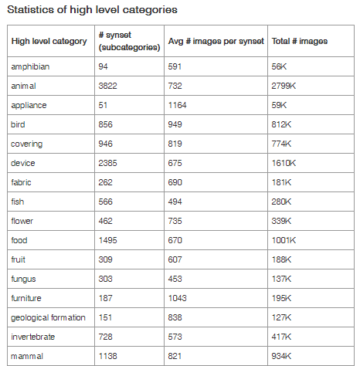

3. Usage Plan
(for research institutions or labs, must specify the target journals or conferences)
⚪ for companies, introduce A.I. products/services to be developed using the granted dataset
⚪ for research institutions or labs, introduce research topics that require the granted dataset (research topics do not have to be ‘new technology using the dataset’. It may be the research and study on the ‘production of dataset’ itself)
⚪ Research institutions or labs must include the name of the target journals or conferences

Ex)
- Health care service that can assist personal health management by checking meal and nutrition information through accurate image recognition
- Food classification technology research or service development for the visually impaired
- Service that provides predictive nutritional check of food for diabetics
- A.I. diet diary for losing weights
- and more...

4. Expected Outcomes
⚪ Development of A.I. algorithms, advancement of research, etc

5. Additional Information
⚪ Submit a photo, video or PPT supplementing the proposed dataset (up to 3 attachments) -> Optional
⚪ Commitment statement or expected things to achieve from the program
⚪ Any other information you may wish to add
Submitting the Application form and Dataset Proposal
following the 『2021 A.I. Training Data Grant Program Guideline』

2020. mm. dd.

Applicant: (Signature)

SELECTSTAR Inc.

